DORRIDGE SURGERY PATIENT PARTICIPATION GROUP

SURVEY & REPORT MARCH 2013

WHAT IS THE PATIENT PARTICIPATION GROUP (PPG)?
The Patient Participation Group has been established and active at Dorridge Surgery for over 13 years.
It is an open membership group that encourages involvement and attendance from all areas of the practice community.
The group has been instrumental in acting as a critical friend advising the practice of the good, and where improvement is required.
The group promotes good health and a higher level of health literacy by encouraging and supporting activities both inside and out of the practice, and promoting preventative medicine.
Our PPG successfully runs an exercise group called ‘Extend’ & a ‘Striders and Strollers’ group – information on both is available in the surgery.
The PPG have also arranged Thai Chi classes that are now fully subscribed to, & have run First Aid courses that have also been fully subscribed to.
The advertising for all of these classes/courses can be found in the surgery & in the newsletter produced quarterly by the PPG (available in surgery & on the website).

PPG AND PRACTICE PROFILE
Over the last 12 years the group has had between 6-7 members, this has now increased to 10, with a larger representation of the 16-44 age group, & change in the male/female split. Some members joined the group at the beginning; some have joined along the way and others more recently. Other members have also left the group due to other commitments or circumstances.
Demonstrating how a Patient Participation Group is Representative
Practice Population Profile | Population Surveyed | PPG Group
Age
19% Under 16 | 1% Under 16 | 0% Under 16
27% 16-44 | 28% 16-44 | 20% 16-44
30% 45-64 | 30% 45-64 | 10% 45-64
11% 65-74 | 20% 65-74 | 50% 65-74
12% Over 75 | 22% Over 75 | 20% Over 75
Ethnicity
93% White | 98% White | 100% White
1% Mixed | 0.03% Mixed | Mixed
2% Asian | 1% Asian | 0% Asian
2% Black | 0.67% Black | 0% Black
1% Chinese | 0% Chinese | 0% Chinese
1% ‘Other’
Gender
49% Male | 33% Male | 40% Male
51% Female | 67% Female | 60% Female

STEPS TO ENSURE GROUP WAS REPRESENTATIVE/REASONS FOR DIFFERENCE IN GROUP AND PRACTICE PROFILE
We encourage participation and a representative make up of the PPG in many ways. The group discusses and debates recruitment and representation on a regular basis.
The PPG quarterly newsletter is used to raise awareness and appeal for membership. We use a specific PPG notice board in the surgery to invite interested patients to contact the practice manager. There will be a “join the group” feature on our practice website and a silent television screen soon to be installed will also promote the PPG/membership. What has been most successful in gaining new members has been word of mouth.
The group only represents patients of a white ethnic group. Our practice population is 93% white and the makeup of the PPG reflects this.
In 2011, for the age range the GP’s actively approached patients from the age groups 16-44 & 45-64 as there was no representation from this group. Through approaching patients opportunistically, in addition to advertising in the quarterly newsletter & on the notice board, a patient studying her A levels joined the group, along with a patient who has links with a local pharmacy. During 2012 we have added another A level student through the links we have we patients & the knowledge of the PPG. We are also aware that these 2 members of the PPG will be leaving for university soon, so have already, through GP contact arranged for another keen A level student to join the PPG in the summer – this will also balance out the male/female representation, as the latest member is male. This demonstrates that the PPG and the surgery are both mindful of, & always looking to review, the make up of it’s members.

PPG FREQUENCY
Our PPG meets face to face within the practice every eight weeks.
The meeting is usually held on a Monday or Tuesday at 7pm, as the PPG members include patients who work full time or are at school. It has recently been agreed to alternate the days between a Monday and Tuesday, and for them to be a little earlier so it suits all members & representatives from the surgery.
The PPG has discussed the survey at 3 separate meetings in October, November & January. This included agreeing the content and questions within the survey and how it was to be distributed.
All meetings are minuted by the group secretary and have begun to be published on the website since October 2012, along with the constitution & newsletters.
The practice team discussed the survey results prior to the PPG meeting on the 5th March 2013 and in particular how we could address areas that needed improvement. The team reviewed 2011/12 action plan, had reviewed the results and comments prior to the meeting and contributed ideas and helped develop the action plan.

PATIENT SURVEY

AREAS OF PRIORITY & HOW THEY WERE DECIDED
The survey was first discussed at a meeting 16/10/2012 to agree a new surgery questionnaire. A further meeting was held on the 26/11/2012 to discuss the relevance of the previous year’s survey & checking that the questions reflected what patients have asked about or queried about the surgery. Each member of the PPG was asked to consider questions they thought relevant in this context. The group chose to continue to focus on key patient priorities, issues and themes. These include access (opening times, ability to book appointments quickly and in advance, telephones) and patient’s experience of the treatment they receive.

SURVEY PROCESS
The PPG agreed to host the survey in the practice for 1 week commencing 14th January. Different members of the PPG came in on different days & at different times in order to obtain a range of feedback from the surgery’s demographic of patients. The secretary of the PPG put together a rota for the members, & a few extra helpers were recruited in the form of relatives/friends who also are patients & were willing to help out during the week.
It was agreed to aim for 30 surveys per GP (5 more than last year), and pre printed surveys were organised so the PPG members could identify which GP was being seen & give out the appropriate survey. The same number of surveys were also allocated to each nurse & our phlebotomist.
The team encouraged patients to complete the surveys and return them into a sealed box at reception.
After the surveys were taken the final results were analysed in house. The Practice Manager and 2 of the members of the PPG took time to review each individual survey, record the result and the comments.
The results were e-mailed to all of the PPG members, & the individual GP’s, and discussed at a meeting held on the 5th March 2013.

RESULTS

305 surveys were collected over 5 days compared with 155 the year before.
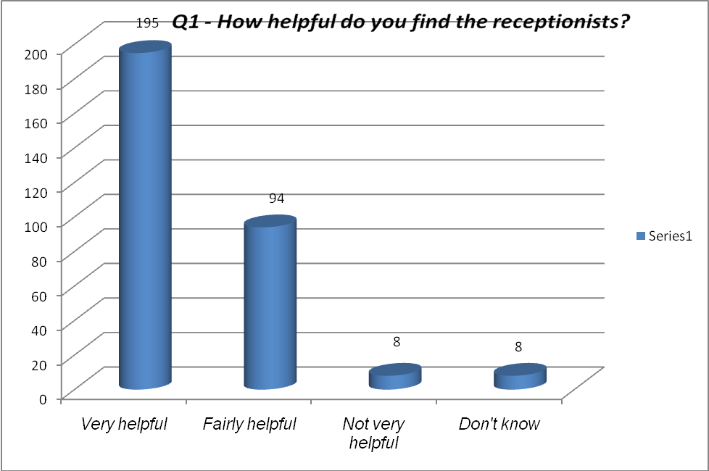
Very – increase of 2% from 62-64%
Fairly – reduction of 6% from 37-31%
Overall positive reduction from 98-95%
(added in a ‘don’t know’ option 2012/13)
(the ‘not helpful’ has increased marginally from 2-2.5%)

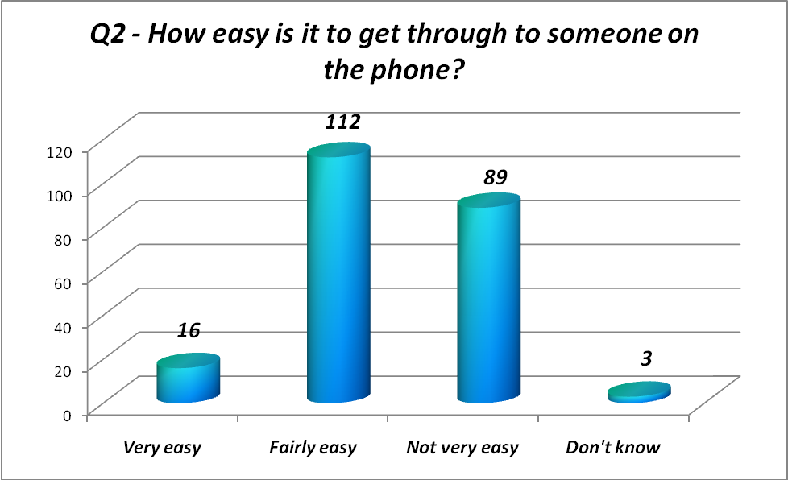

Very – reduction of 5% from 10-5%
Fairly – increase of 7% from 30-37%
Not Very – reduction of 2% from 57-55%
Don’t know – increase of 1% from 2-3%
(overall positive increase of 2% from 40-42%)

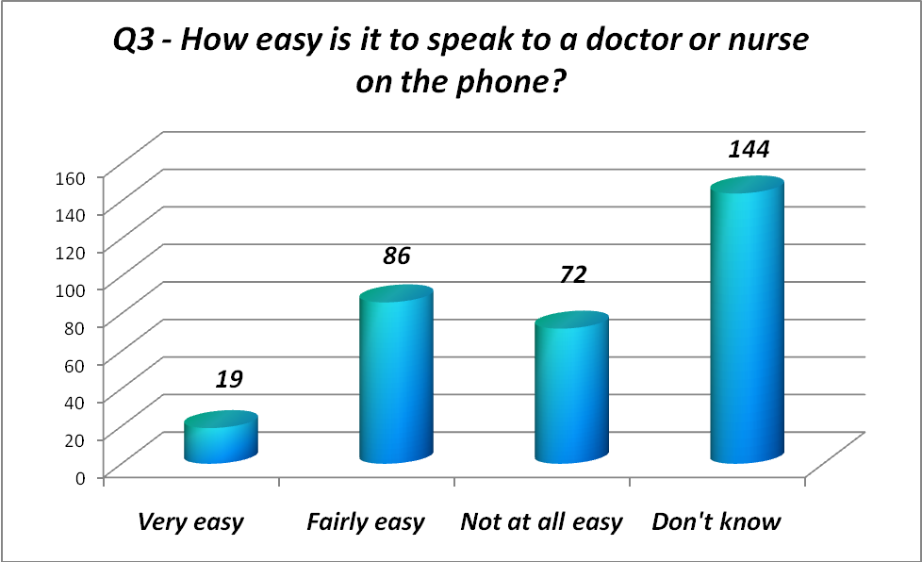
Very easy – reduction of 3% from 9-6%
Fairly easy – increase of 1% from 27-28%
Not at all easy – increase of 5% from 19-24%
Don’t know (increase of 3% from 44-47%)
(overall positive reduction of 2% from 36-34%)

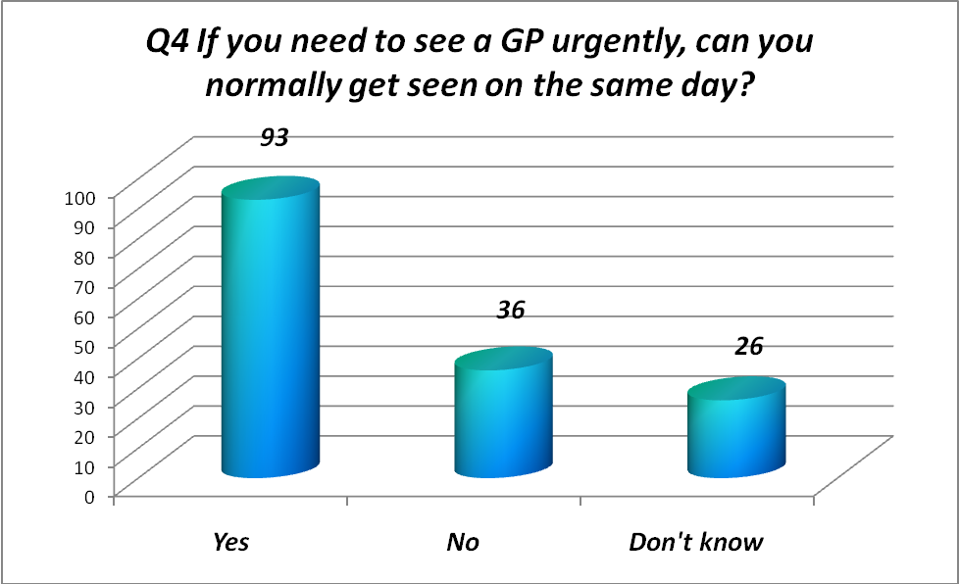
‘Yes’ – increase of 9% from 60-69%
‘No’ – reduction of 6% from 23-17%
‘Don’t know’ – 17% 2011/12 – 48% 2012/13

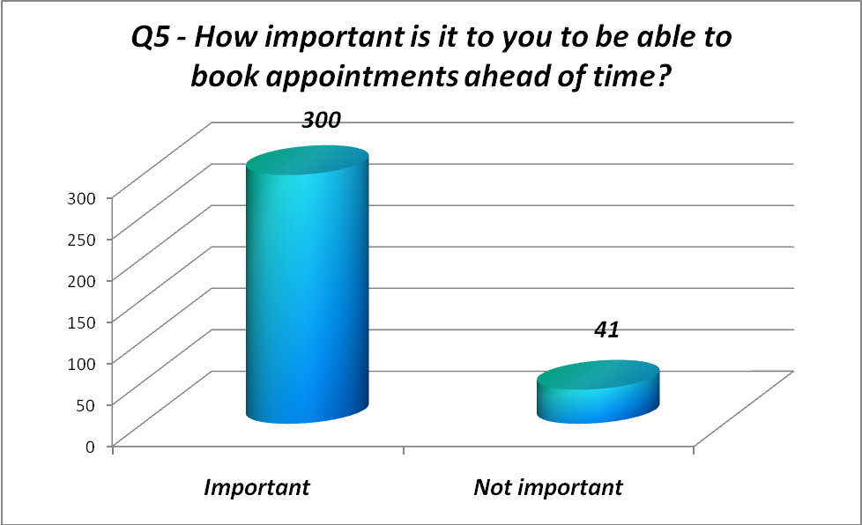
Important – increase from 77-98%
Not important (decrease from 23-2%)

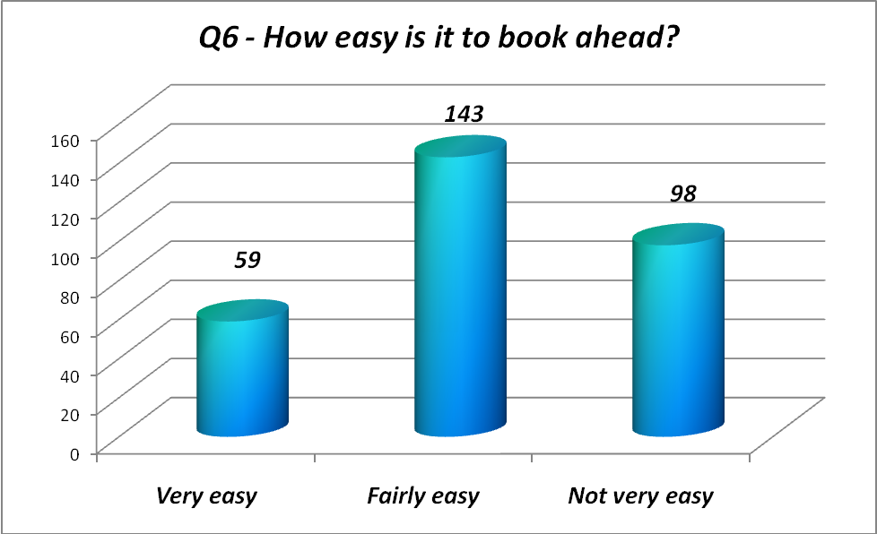
Very easy – reduction of 6% from 26-20%
Fairly easy – increase of 3% from 45-48%
Not very easy – increase of 3% from 29-32%

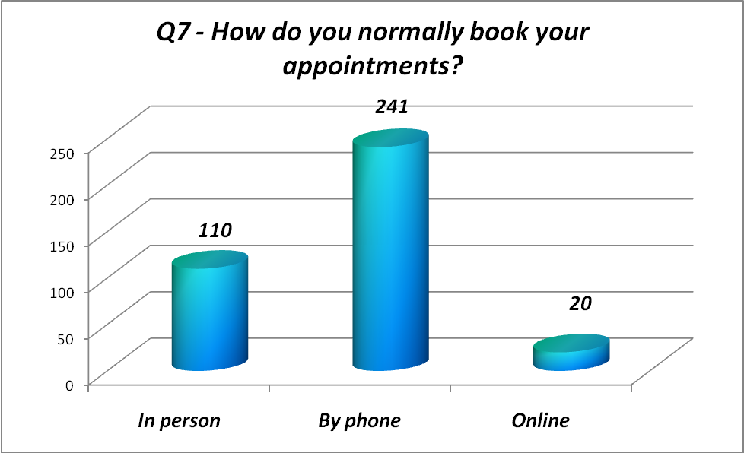
In person remains the same at 30%
65% book by phone compared to 68% last year
5% book online

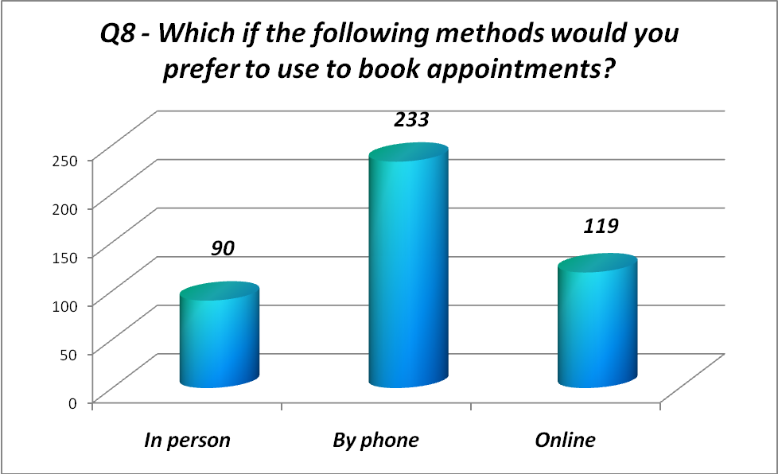
There is a shift from wanting to be able to book on the phone.
2011/12 had 84% wanting to book by phone
2012/13 has 53% wanting to book by phone
27% would like to book online (compared to 5% using this method now)

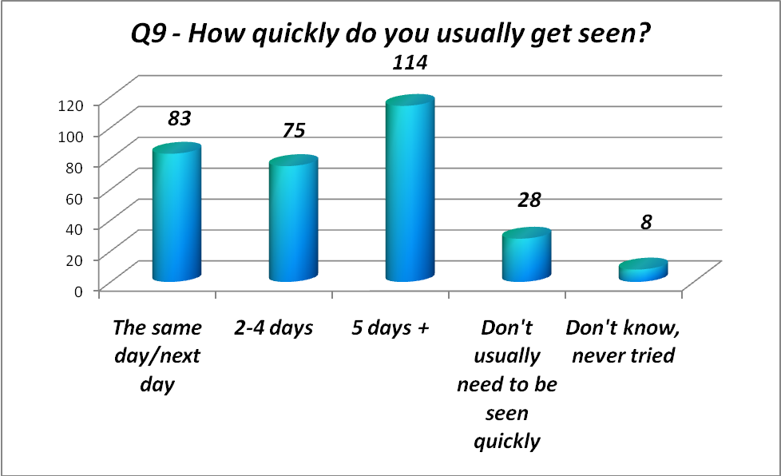

Same/next day – increase of 6% from 21-27%
2-4 days – reduction of 7% from 31-24%
5 days+ - increase of 2% from 35-37%
(don’t need to be seen quickly – increase of 2% from 7-9%
(don’t know, never tried – reduction of 3% from 6-3%)

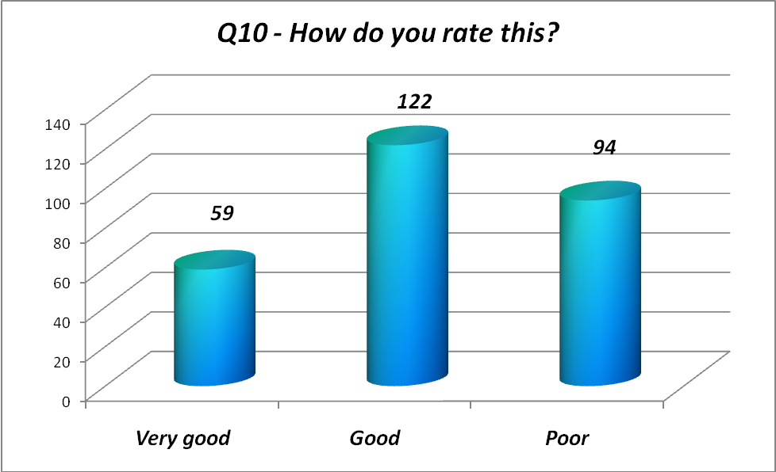
Very good – increase of 2% from 19-21%
Good – reduction of17% from 61-44%
Poor – increase of 14% from 20-34%

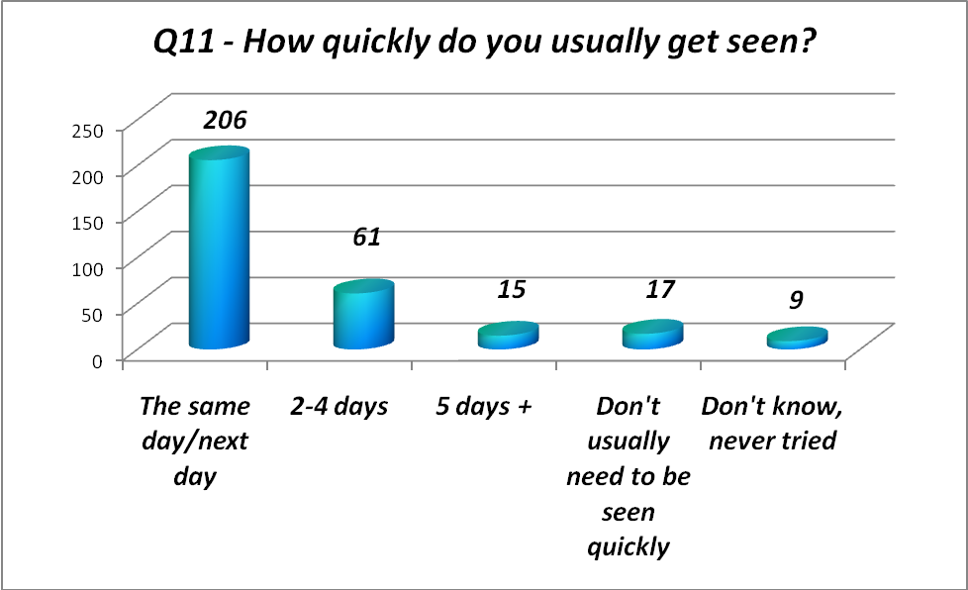
Same/next day – increase of 6% from 61-67%
2-4 days – reduction of 5% from 25-20%
5 days+ - reduction of 3% from 8-5%
(don’t need to be seen quickly – increase of 2% from 3-5%)
(don’t know, never tried – approx same)

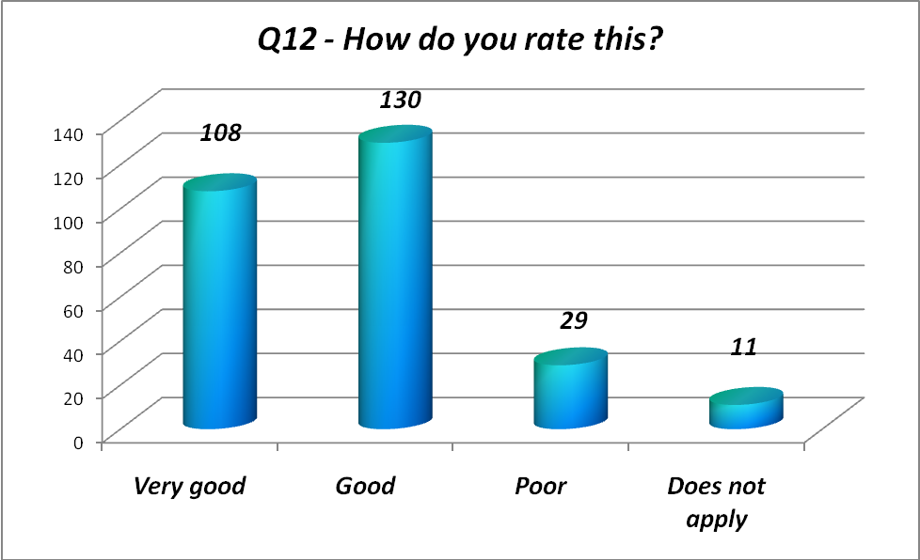
Very good – increase of 7% from 32-39%
Good – reduction of 4% from 51-47%
Overall positive increase of 3% from 83-86%
Poor – same 10%

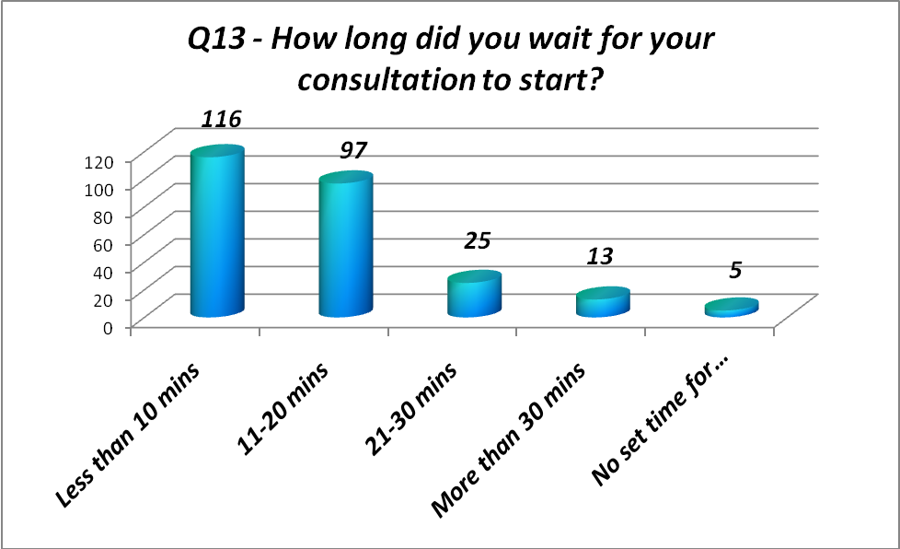
< 10 mins – increase of 10% from 35-45%
11-20 – reduction of 7% from 45-38%
21-30 – same (10%)
30+ - reduction of 2% from 7-5%
(No set time – reduction of 1% from 3-2%)
83% of patients surveyed waited less than 20 minutes to be seen (3% improvement on 2011/12)

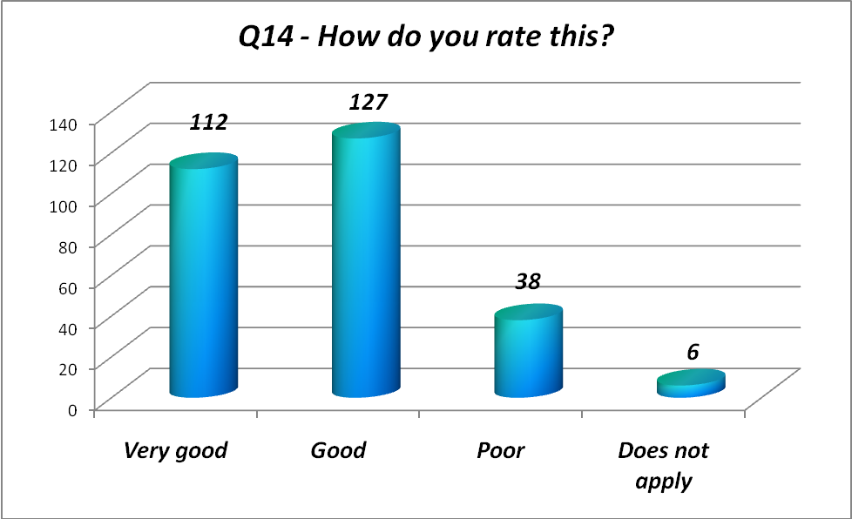
Very good – increase of 7% from 33-40%
Good – reduction of 5% from 50-45%
Overall positive increase from 83-85%
Poor – increase of 1% from 12-13%
Does not apply – 5-2%

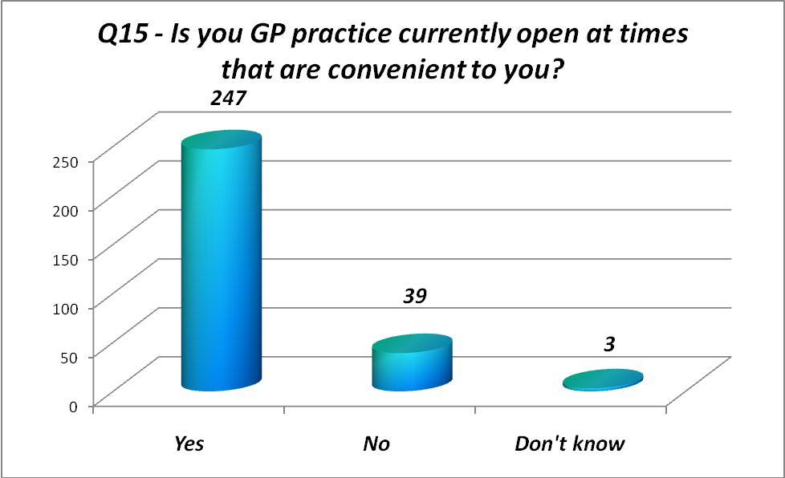
Yes – improvement of 6% from 79-85%
No – same (13%)
Don’t know – reduction of 6-2%

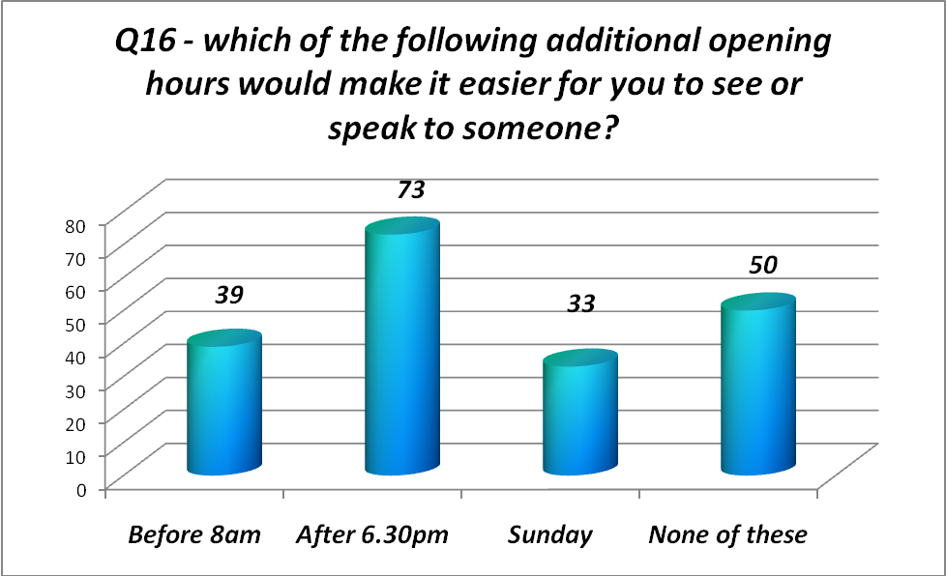
Before 8am – same 20%
After 6.30pm – increase of 16% from 21-37%
Sunday – increase of 11% from 6-17%
None of these – reduction from 54-26%

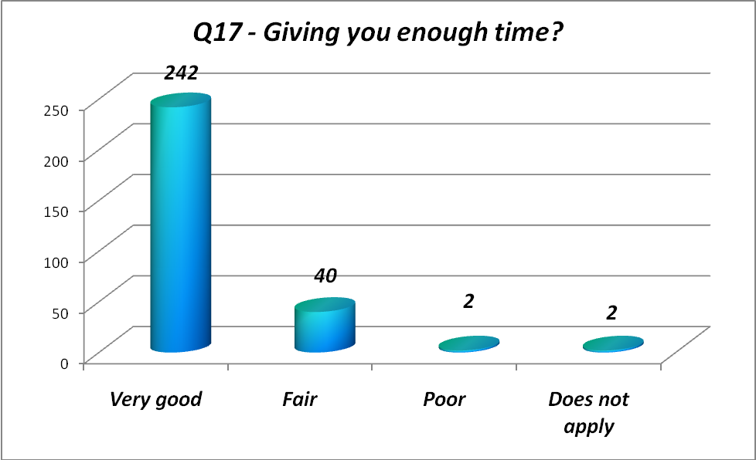
Very good – increase of 14% from 71-85%
Fair – reduction of 6% from 20-14%
Poor- 0-<1%
Does not apply
Overall increase of 5% from 94-99%

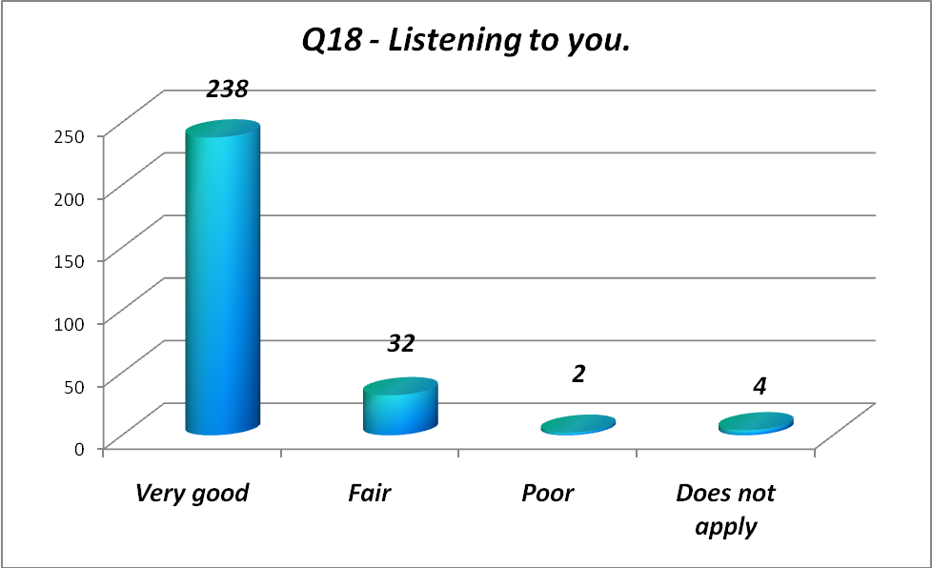
Very good – increase of 5% from 80-86%
Fair – reduction of 2% from 14-12%
Poor- 0-<1%
Does not apply
Overall increase of 4% from 94-98%

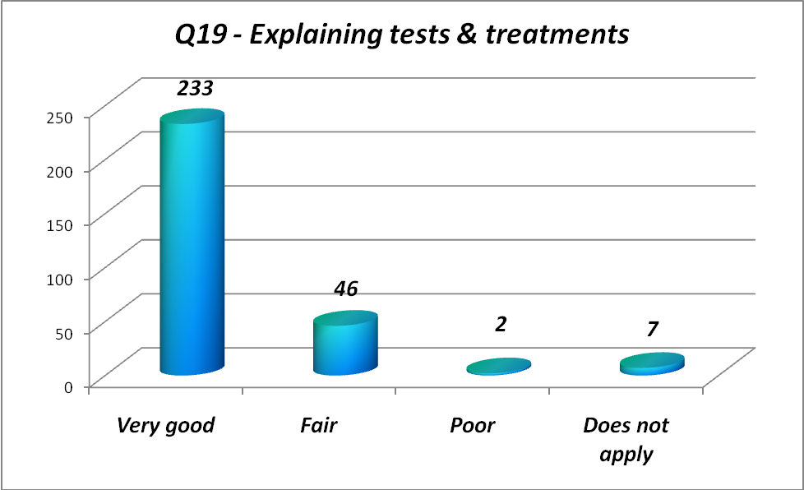
Very good – increase of 5% from 76-81%
Fair – same (16%)
Poor – 0-<1%
Does not apply
Overall increase of 5% from 92-97%

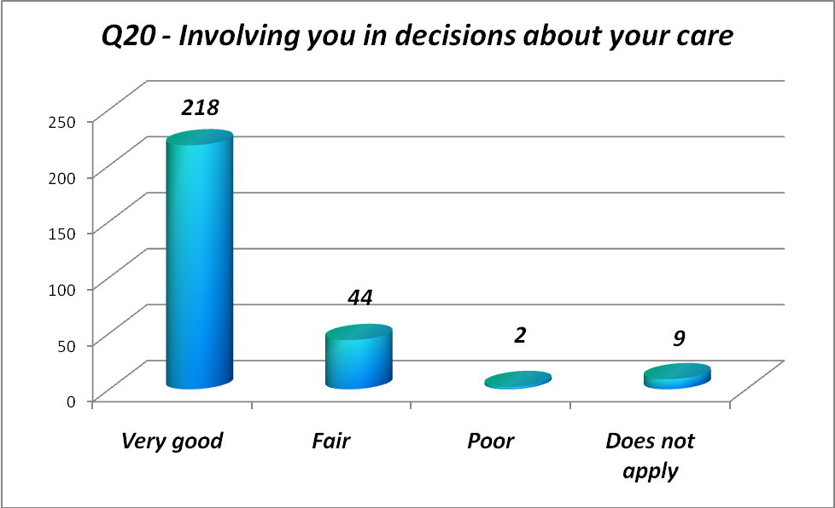
Very good – increase of 4% from 76-80%
Fair – increase of 1% from 15-16%
Poor – 0-<1%
Does not apply
Overall increase of 5% from 91-96%

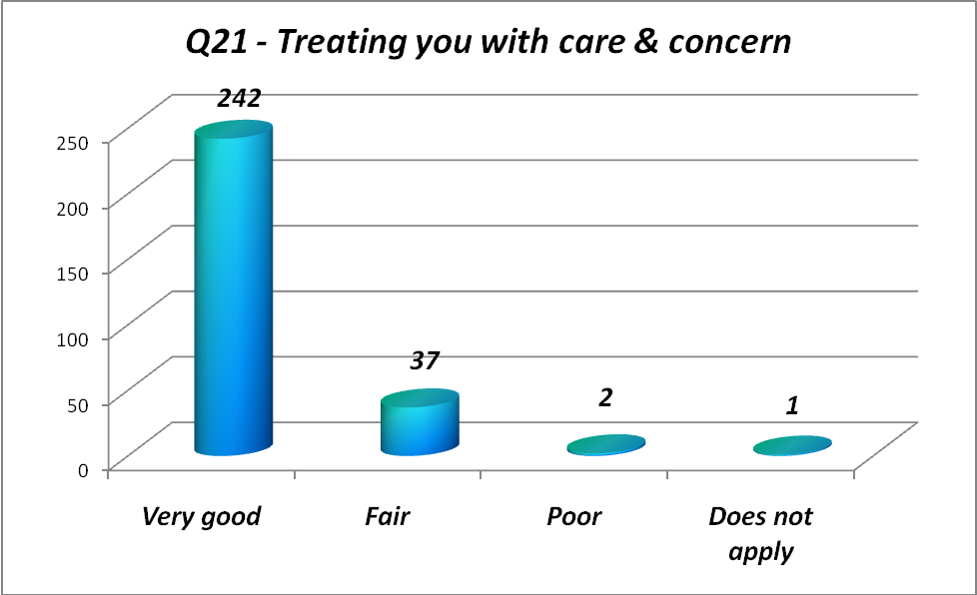
Very good – increase of 10% from 76-86%
Fair – reduction of 2% from 15-13%
Poor – 0-<1%
Does not apply -
Overall increase of 8% from 91-99%

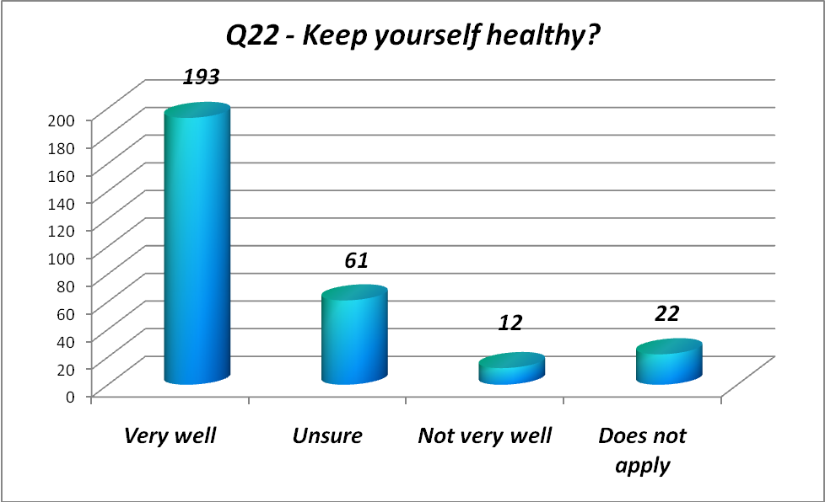

Very well – same (67%)
Unsure- reduction from 24-21%
Not very well – increase of 3% from 1-4%
Does not apply (increase of 5% from 71-76%)

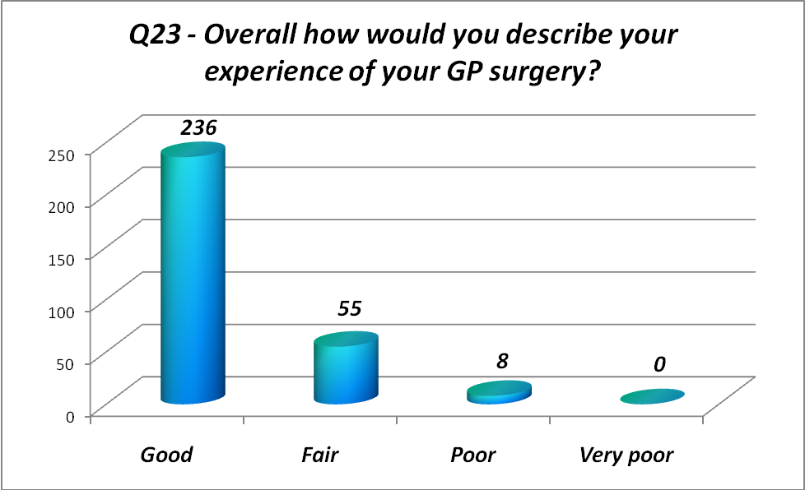
Good – Increase of 2% from 77-79%
Fair – reduction of 4% from 22-18%
Poor - increase <1%-3%
Very poor 0
Overall reduction from 99-97% in overall satisfaction

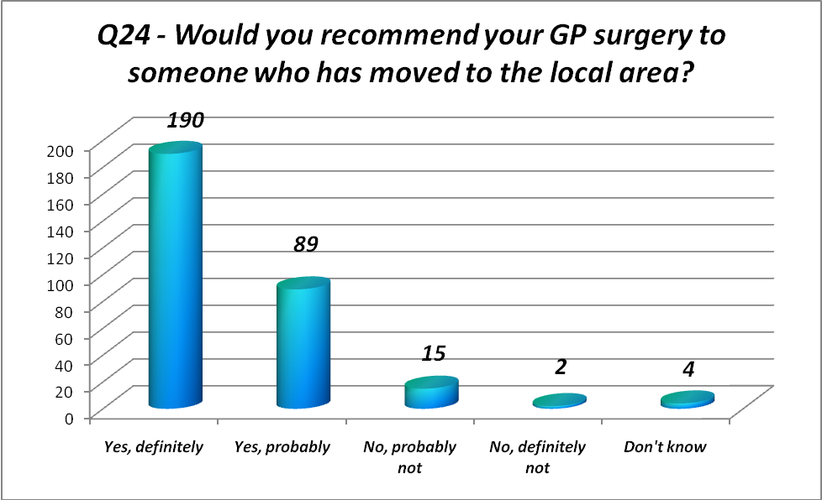
Yes, definitely – increase of 2% from 61-63%
Yes, probably - reduction of 2% from 32-30%
No, probably not – increase of 3% from 2-5%
No, definitely not- reduction from 1% to <1%
Don’t know - reduction 3-1%
Overall same positive 93%

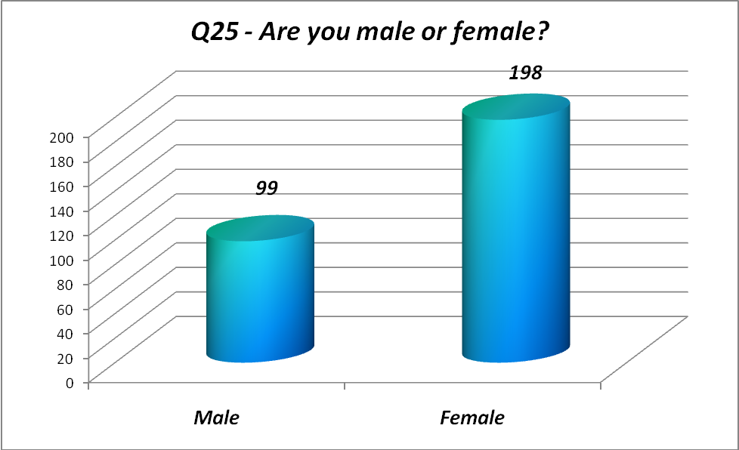
Male – reduction of 3% from 36-33%
Female – increase 3% from 64-67%

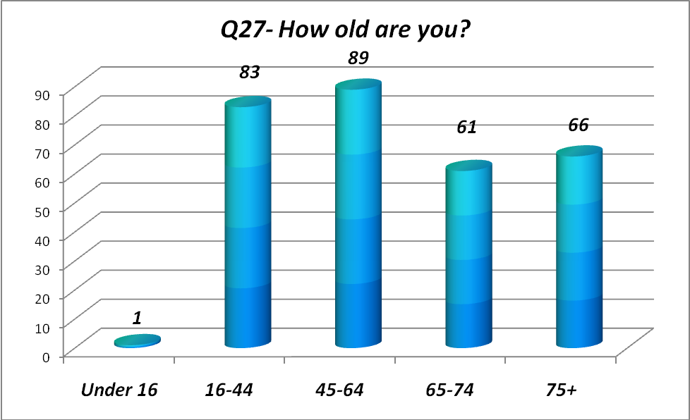
<16 – 3%-<1%
16-44 – reduction of 5% from 33-28%
45-64 – increase of 2% from 28-30%
65-74 – increase of 1% from 19-20%
75+ - increase of 4% from 18-22%

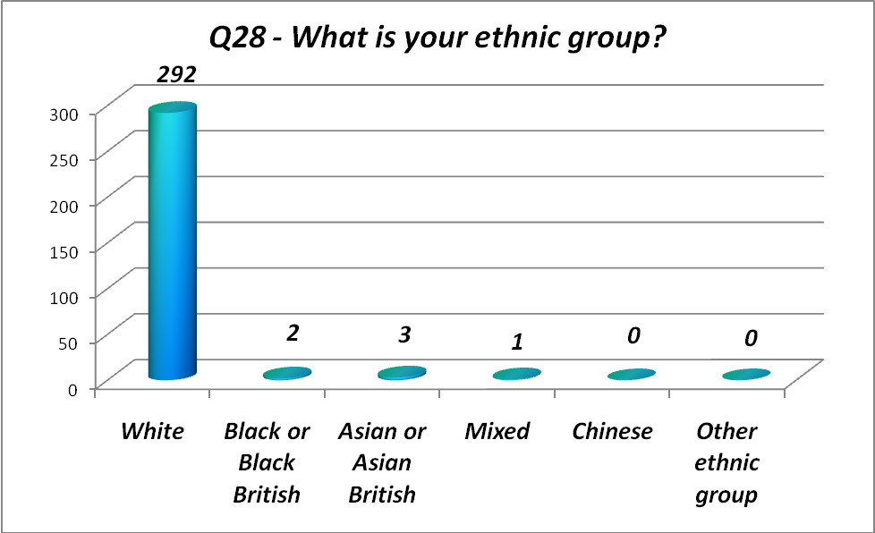
White – increase 95-98%
Black or Black British – increase <1% (0-2)
Asian or Asian British - <1%-1% increase (1-3)
Mixed – reduction 3-<1%
Chinese – reduction <1%-0
Other ethnic group – reduction <1%-0

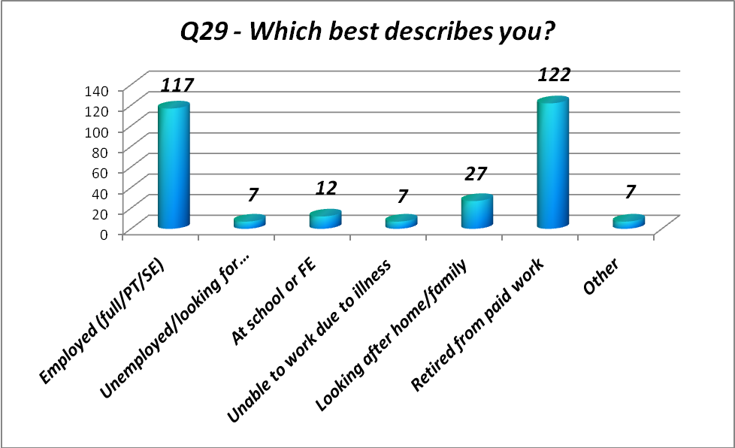
Employed – reduction of 5% from 44-39%
Unemployed/looking for work – increase from <1%-2%
At school or FE – reduction of 3% from 7-4%
Unable to work due to illness – increase 1% from 1-2%
Looking after home/family – increase 4% from 5-9%
Retired from paid work – same (41%)
Other – increase from <1% - 2%

DISCUSSION ABOUT RESULTS
The full results and action plan were discussed and agreed with the PPG at the meeting 5/3/12 held at the surgery. Areas highlighted for focus were as follows –
- There has been an overall positive increase in how easy it is to get through on the phone, from 40-42%
- 98% of respondents felt it is important to be able to book appointments ahead of time, compared to 77% the same time last year
- Respondents wanting to book face to face has not changed since last year, but 5% of respondents now book online.
- There is a shift from patients wanting to be able to book on the phone – 2011/12 had 84% wanting to book by phone, this is now 53% with 27% wanting to be able to book online.
- The answers around care given by clinicians has risen to between 96 & 99% from 91-94% last year
It was felt that although the results themselves show a positive shift in telephone response, and an overall positive result in the standard of care & treatment from the clinicians, the comments that came with the surveys gave strong feedback around the ability to ring, & to get a suitable appointment.
The members of the PPG felt that, even though over the 9 months prior to the survey being conducted, a number of on line facilities have been introduced, patient awareness of these services still seems to be lacking. The PPG also felt that the surgery needs to consider how it gets messages out to its patients, including the extent of & setting the expectations of what services the surgery provides.
The group came to the conclusion that the booking & availability of appointments, as well as being able to get through on the telephone are down to a number of wider factors than just the telephone system & number of appointments within the system. The discussion led onto ensuring the patients are aware that if they have a chronic condition or have a follow up with a GP then it should be possible for them to continue to see the GP of their choice where possible. The surgery will look at a recall plan for 2013 to ensure patients undergoing care for a chronic condition are called in on a regular basis determined by the clinician, & therefore managing the number of patients attending at any one time for certain conditions. For patients wanting to be seen immediately there should be an understanding that they need to be prepared to see any GP.
It was also felt that a number of methods could be employed to share information with patients around services available & changes. ‘Information messages’ on the telephone system, better use of the SMS option (over 4000 patients have their mobile number recorded, these could be used to inform patients, for example, when the survey is available on the website), use of repeat prescription tear off slip, television screens in waiting rooms. Standard letters sent by the surgery etc, as well as the quarterly newsletter content. With the number of free text comments made by patients during the survey it was also felt that a suggestion box may be a good idea, so patients have an avenue throughout the year to put their comments/suggestions to the practice.
The PPG are also considering hosting an ‘event’ later in the year, in the surgery, designed to inform patients of the care & treatment available to them & to give them tips on how the surgery runs & how to make best use of online services etc.
In addition, there have been no changes to the telephone system, which is a cause of frustration to many patients. The feedback from patients is that trying to get through at 8am is difficult, & therefore the surgery will ensure priority is given to those needing an appointment or to arrange a home visit. This will mean initially patients who ring between 8am & 10.30 being asked to call back if they are not booking an appointment or home visit. Specifically patients wanting blood test/test results will be asked to call back after 2.30pm. The telephone system will be reviewed to put in place options (see action plan) that are intended to alleviate the bottleneck that can happen on the telephone, especially early in the morning.
The PPG themselves have done a tremendous amount of work with encouraging the improvement & education in the health of our patients, and the information available to them in the surgery has vastly improved since a member of the surgery team to control of the posters & up to date/relevant information in the surgery.
Having reviewed the 2011/12 action plan it was agreed that 3 out of 4 of the areas on the plan had been achieved; however the advertising of those achievements perhaps requires a further push.
The 4th element of the action plan was not explored, & therefore takes a top slot over everything else for 2013 – exploring & implementing the improvements of the telephone system.
The action plan below shows the previous actions agreed & what has happened with them (this can be found following the 2012/13 plans).

ACTION PLAN
Action | Task | Timeline
Improve current telephone system | Agreed with PPG that a line for ‘appointments/home visits’, a line for ‘admin’ (i.e. queries regarding medical reports) & a line for the medical secretaries would be very beneficial.  Preset ‘information messages’ to be played alongside on hold music, to advise patients of any current news & that results are only available after 2.30pm to be built in,. | By 31/5 telephone company to have trained staff on how to set up telephone system with options.
Introduce a ‘recall plan’ | For all patients with a chronic condition who require regular reviews with a GP. Surgery to pro-actively invite these patients in on a frequency determined by their clinician depending on the nature of their condition | Plan on place by 30th April 2013
Look at ways to inform patients of the services offered & changes that have taken place, to ensure people are aware of the options open to them | More updates to website  Use of television screen in waiting areas to pass on messages  Use of repeat prescriptions to bring attention to changes/new services available  Rotate changes in information using the television screen/repeat scripts | Immediate update with % of patients attending appointments. Ongoing for other information. 31st Mar for survey results & action plan  Ongoing  Immediate addition of website address.  Ongoing
Introduce a suggestion box in the reception area | Allow patients to leave feedback on a more regular basis | WEF June 2013
Review the way we conduct surveys | Consider with PPG a number of short surveys, possibly using the website as the medium, throughout 2013, to build up feedback on specific areas of interest & the opportunity to act earlier | Next PPG meeting May 2013.
Run an event in the surgery to inform patients of services | PPG to consider content & organisation of an event later in 2013 to advise patients of what they can get/expect from the surgery & how to make the most of the new services/changes introduced. | Towards end 2013.
2012:  Appointment availability | Review how soon appointments are available, so patients have a choice of same day, next few days as well as in advance for routine follow ups | New system to be in place for 1st May as a result of meetings held with the PM & GP’s 17/3 & 2/4.  ACHIEVED MAY 2012
2012:  Make some appointments available on the Internet | Agree portion of available appointments that will be made available over the internet, & set up the process to allow patients to sign up for the service. | In place for June 2012  APPOINTMENT BOOKING WENT LIVE AUGUST 2012- ALL ROUTINE GP APPOINTMENTS AVAILABLE UP TO 5 WEEKS IN ADVANCE
2012  Information available to patients (TV & Website) | To support health messages & messages about the surgery, 2 silent screens will be installed. This, along with development of the website will give patients access to more information by through other media, making information more accessible to all. | Television screens installed by 30th April.  Website development ongoing (with ability to use to book appointments online by June 2012  WEBSITE UPDATED WITH ALL NEW DEVELOPMENTS PLUS PPG MINUTES & NEWSLETTERS.
2012:  Better use of telephone system | PM to consider what menu ‘options’ to be introduced. The numbers of options are to be kept to a useful minimum, as well being informative.  (this was agreed by the PPG at the meeting 6/3/12) | PM to meet with 1 other member of staff to set up the new options, as a result of input from the PPG at 6/3/12 meeting.  Effective by May 2012

ACCESS

OPENING HOURS – Building Physically Open
Monday to Friday 0800-1830
Saturday open 0830 - 1130

EXTENDED HOURS
Open daily with last appointment available at 6.30pm. 1-2 nurses offering bookable appointments
Saturday open 0830 – 1130 – 1 GP offering bookable appointments

ACCESS TO SERVICES
Dorridge Surgery, 3 Avenue Road, Dorridge, Solihull, B93 8LH
Main Telephone Number 01564 776262 for all enquiries including booking appointments in advance and same day.
Appointments can be booked in person via the telephone or with online access (available by initial visit to the surgery to be issued with a username & password).
When the surgery is closed outside of our on call hours 0800 – 1830 Monday to Sunday the telephone line, website and surgery front door provide the telephone number for the out of hours GP service called Badger. This telephone number is 0300 555 0303

PUBLICATION OF THE REPORT
The patient survey is available on www.dorridgesurgery.co.uk.
This action plan will be published on the same practice website, & will be available as hard copy in the surgery. A copy will be sent to Solihull Primary Care Trust.
This will all be in place by March 31st 2013.

